Reading the dataset from excel format
Code:
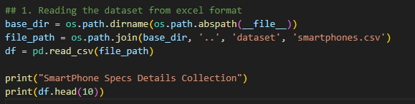

Output:
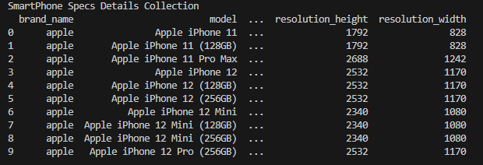

Display DataType of resolution_width column
Code
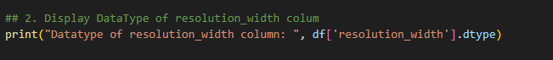
Result

Renaming the column names
Code:
Result:
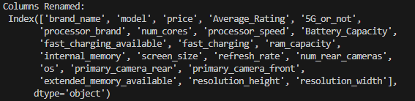

Add additional column
Code:
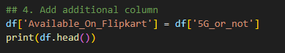
Result:
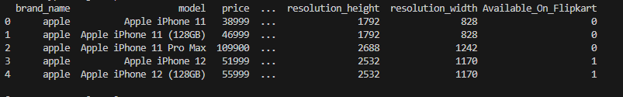

5. Find correlation
Code:
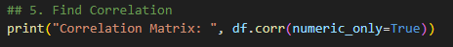
Result:
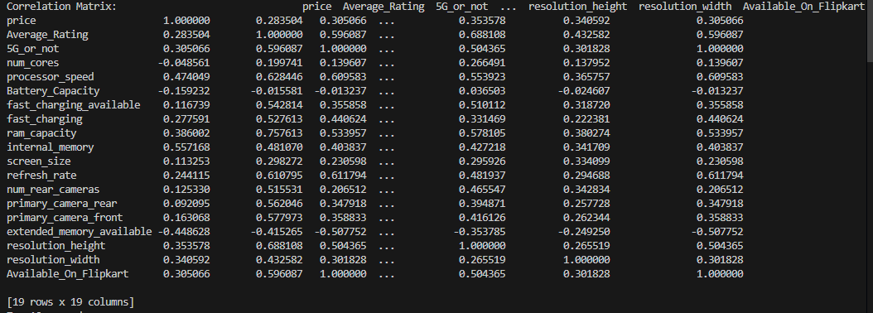

6. Reading top 10 and bottom 10 records
Code:
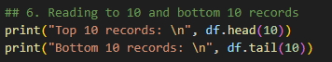
Result:
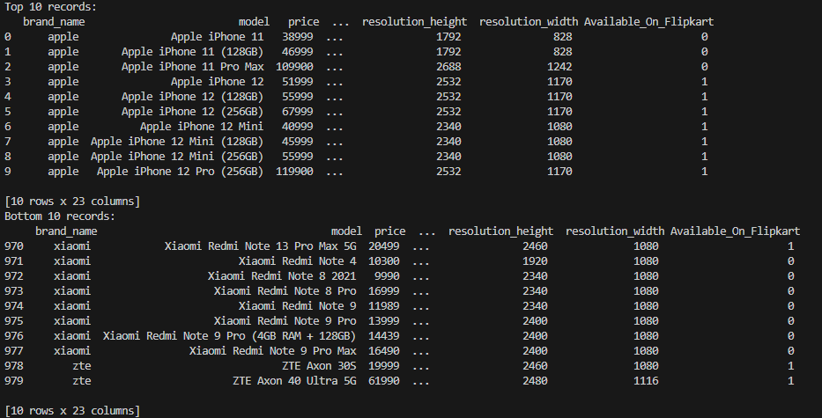

7. Reading the header
Code:
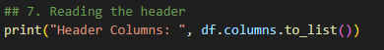
Result

8. Reading data on column basis
Code:
Result:
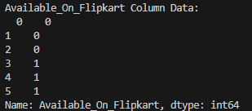

9. Reading specific data
Code:
Result:

10. Reading data of a specific tuple based on a) index ranges b) specific index
Code:
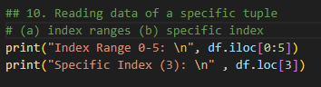
Result:
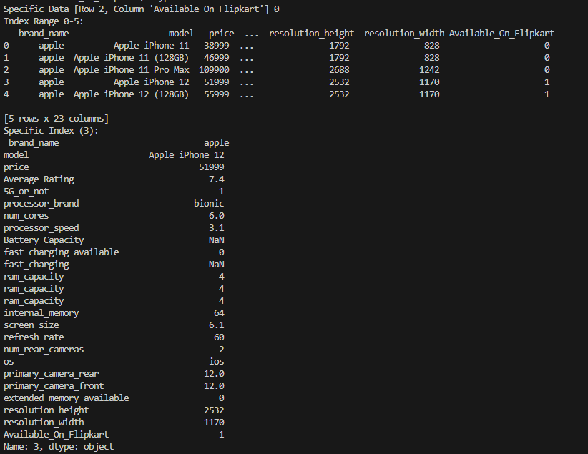

11. Rows with indexes 3 to 7

Code: 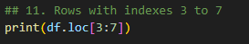

Output: 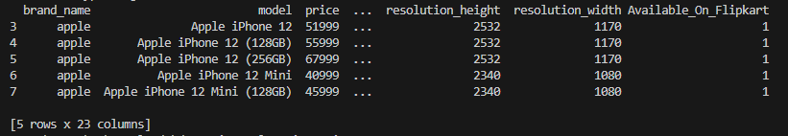

12. Display rows with indexes 5 to 0 (Reverse Order)

Code
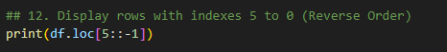
Output
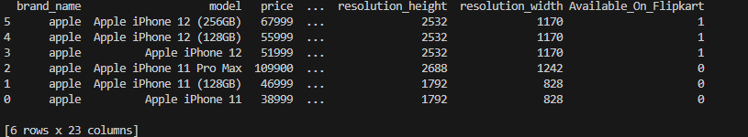

13. Display rows with odd indexes from 1 to 7
Code:
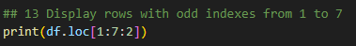
Output:
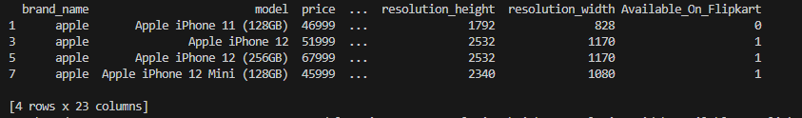

14. Display all the rows where “any condition”
Code:
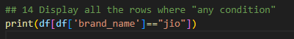
Output:
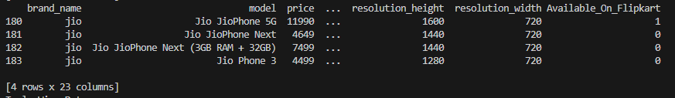

17. Display shape attribute
Code:
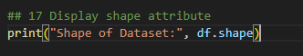
Output:

